**Introduction to ML**

1. **What is ML ?**

Part of AI .Focuses on design of systems and allowing systems to learn from past experiences and predict and take the necessary actions/Decisions . The application will act as a data driven program rather than using any external program.

1. **Difference between AI(Artificial Intelligence) , ML(Machine Learning) and DL(Deep Learning)**

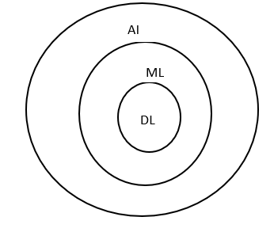

Ex : AI – Machine to mimic human behavior – Alexa

ML- Allow machine to access data and let machine learn and predict -Voice processing

based on accent

DL – To achieve more accuracy

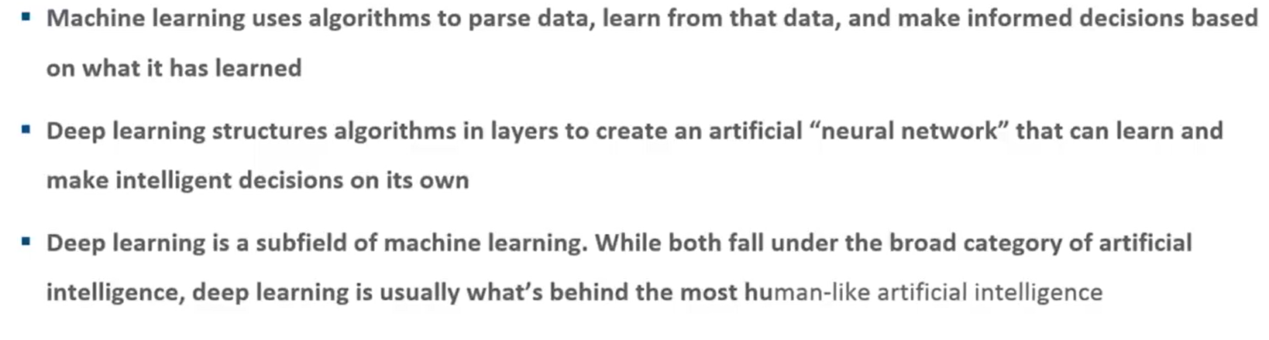

1. **Types of Machine Learning**
2. types

* Supervised Learning
* Unsupervised Learning
* Reinforcement Learning

**Supervised Learning**

Input x

Output y

Y=f(x)

supervised learning comes from the idea that an algorithm is learning from a training dataset, which can be thought of as the teacher.

Different input data having attributes .output value can be discrete ,real or continuous .

Supervised learning classified into two categories of algorithms:

* **Classification**: A classification problem is when the output variable is a category, such as “Red” or “blue” or “disease” and “no disease”.
* **Regression**: A regression problem is when the output variable is a real value, such as “dollars” or “weight”.

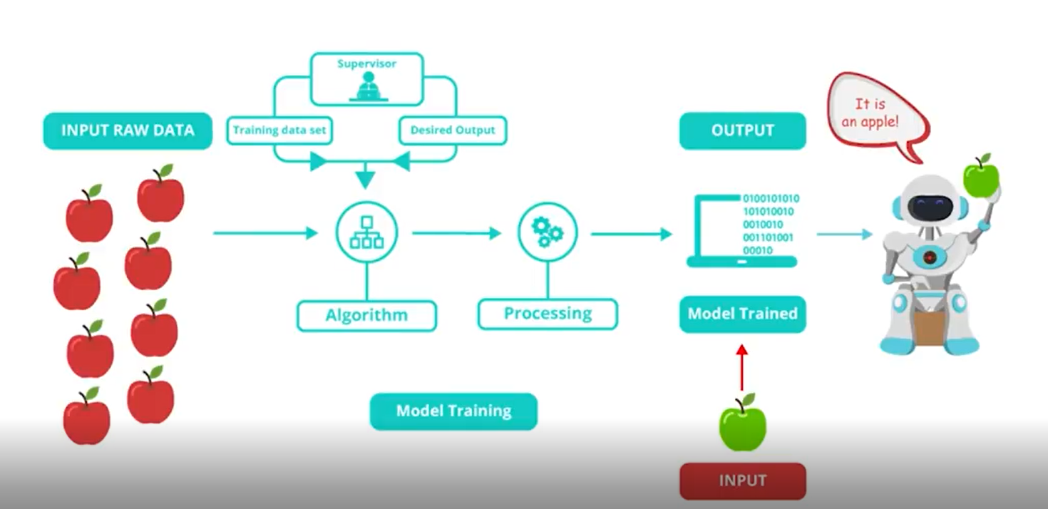

Provided Red apples as input(Training data) and during execution machine determines green apple as apple as well.

Supervised learning is a learning in which we teach or train the machine using data which is well labeled that means some data is already tagged with the correct answer. After that, the machine is provided with a new set of examples(data) so that supervised learning algorithm analyses the training data(set of training examples) and produces a correct outcome from labeled data.

**Algorithms**

1.Linear regression

2.Random forest

3.Support vector machines

Examples of Supervised learning

1.Alexa

2.Biometric

3.Weather Prediction

4.Banking (will give loan to a person or not)

5.Healthcare (Patient ->readmission required or not based on previous admission history)

6.Retail(Product->frequently bought by customer by checking previous transactional data

**Unsupervised Learning**

Unsupervised learning is the training of machine using information that is neither classified nor labeled and allowing the algorithm to act on that information without guidance. Here the task of machine is to group unsorted information according to similarities, patterns and differences without any prior training of data.

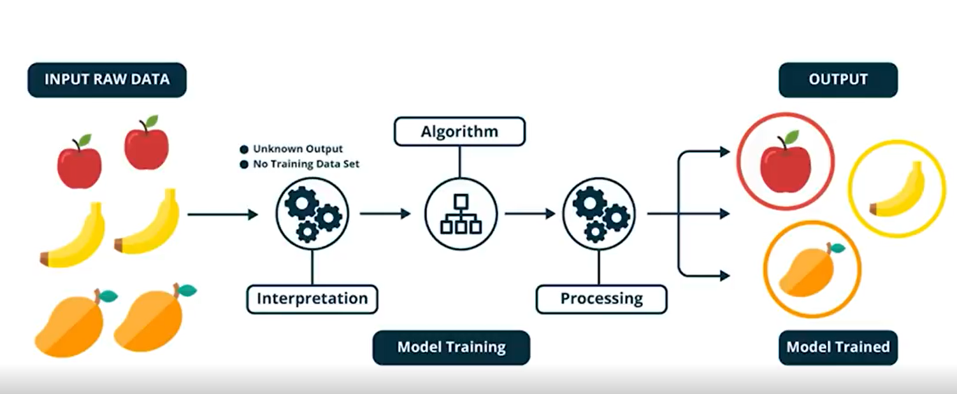

Only input is provided in training data set . no output is provided .

Based on input algorithm divides it into clusters .

It can only categorize but can not label it as apple /banana /mango because we did not provide /feed input label .

Unsupervised learning classified into two categories of algorithms:

* **Clustering**: A clustering problem is where you want to discover the inherent groupings in the data, such as grouping customers by purchasing behavior.
* **Association**: An association rule learning problem is where you want to discover rules that describe large portions of your data, such as people that buy X also tend to buy Y.

Algorithms are

1.Apriori

2.K means

3.Hirarchical clustering

Example :

1.Healthcare - Categorize MRI data of Patient –Normal/Abnormal

2.Retail – Recommend products based on past purchase

3.Banking -Categorize customers based on credit score

**Reinforcement Learning**

It is about taking suitable action to maximize reward in a particular situation. It is employed by various software and machines to find the best possible behavior or path it should take in a specific situation. Reinforcement learning differs from the supervised learning in a way that in supervised learning the training data has the answer key with it so the model is trained with the correct answer itself whereas in reinforcement learning, there is no answer but the reinforcement agent decides what to do to perform the given task. In the absence of a training dataset, it is bound to learn from its experience.

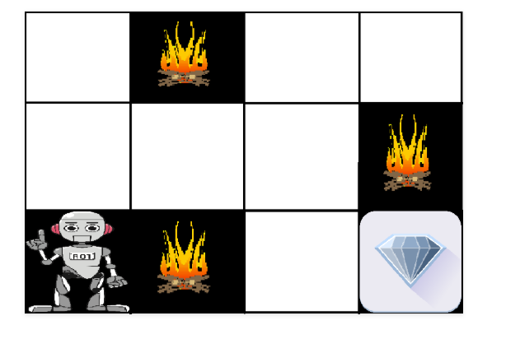

The above image shows the robot, diamond, and fire. The goal of the robot is to get the reward(diamond) and avoid the hurdles (fire) . The robot learns by trying all the possible paths and then choosing the path which gives him the reward with the least hurdles. Each right step will give the robot a reward and each wrong step will subtract the reward of the robot. The total reward will be calculated when it reaches the final reward that is the diamond.

* Input: The input should be an initial state from which the model will start
* Output: There are many possible output as there are variety of solution to a particular problem
* Training: The training is based upon the input, The model will return a state and the user will decide to reward or punish the model based on its output.
* The model keeps continues to learn.
* The best solution is decided based on the maximum reward.

Reinforcement learning is all about making decisions sequentially. In simple words we can say that the output depends on the state of the current input and the next input depends on the output of the previous input.

In Reinforcement learning decision is dependent, So we give labels to sequences of dependent decisions

Example: Chess game

Example in Banking – Best possible offers for a customer

Types of Reinforcement: There are two types of Reinforcement:

1. Positive –  
   Positive Reinforcement is defined as when an event, occurs due to a particular behavior, increases the strength and the frequency of the behavior. In other words, it has a positive effect on behavior.

Advantages of reinforcement learning are:

* + Maximizes Performance
  + Sustain Change for a long period of time

Disadvantages of reinforcement learning:

* + Too much Reinforcement can lead to overload of states which can diminish the results

1. Negative –  
   Negative Reinforcement is defined as strengthening of a behavior because a negative condition is stopped or avoided.

Advantages of reinforcement learning:

* + Increases Behavior
  + Provide defiance to minimum standard of performance

Disadvantages of reinforcement learning:

* + It Only provides enough to meet up the minimum behavior